**Name**:Samah Hamed Mohamed Mohamed

**B.N/**363

**Date**: 6-6-2021

**Topic**: Database Systems

**Application Brief**:

I chose this topic because data storage for all sites depends on it.

**GitHub-Link:**

**GitHub-Page(Published Website):**

**Screenshots**:

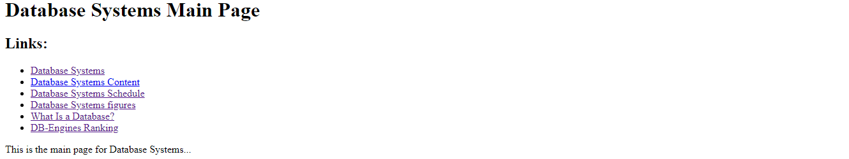

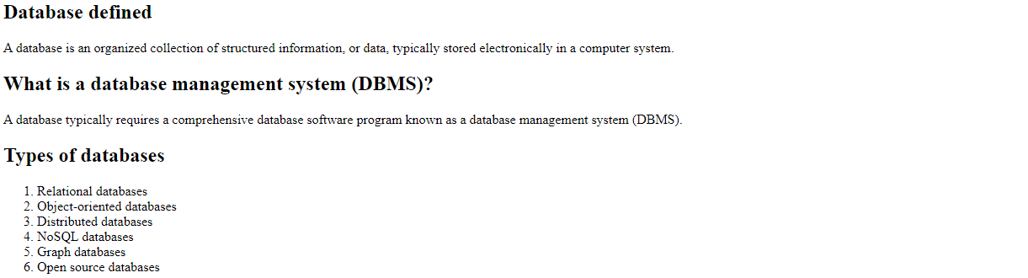



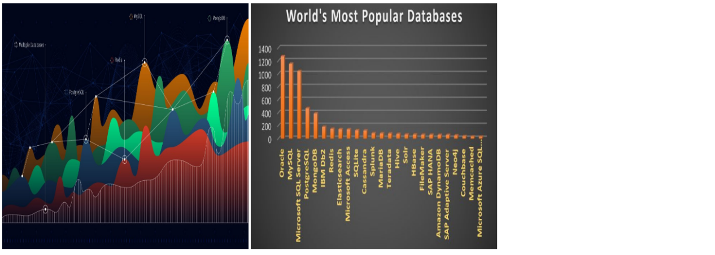

**Source Code**:

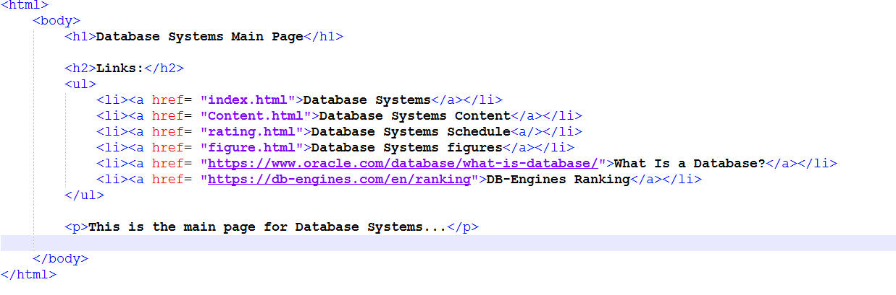

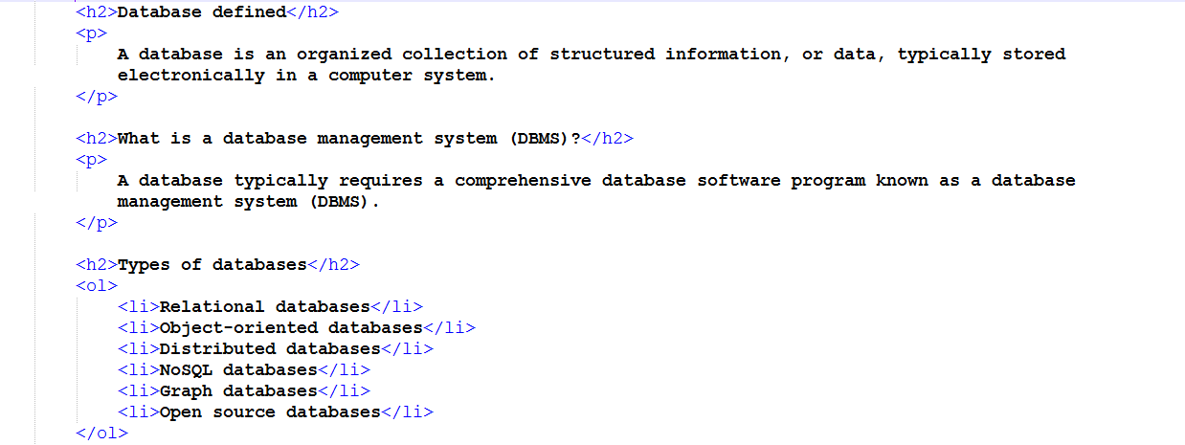

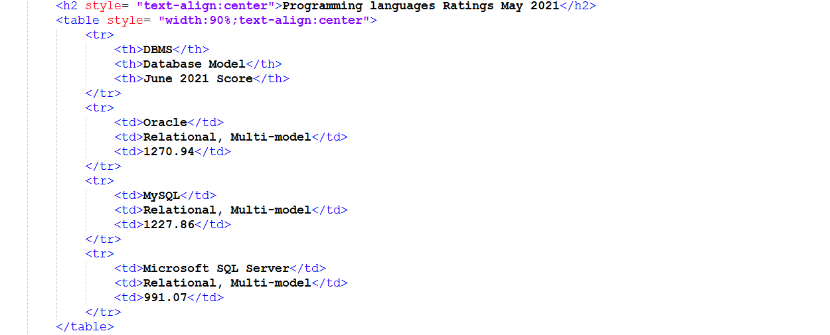

8